**Project Design Phase-II**

**Technology Stack (Architecture & Stack)**

| Date | 11 May 2023 |
| --- | --- |
| Team ID | NM2023TMID11342 |
| Project Name | COVID VISION: Advanced COVID-19  Detection from lung x-ray with Machine learning or Deep learning |

**Technical Architecture:**

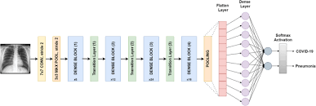

**Table-1 : Components & Technologies:**

| **S.No** | **Component** | **Description** | **Technology** |
| --- | --- | --- | --- |
|  | User Interface | The user interacts with the UI to choose an image. | HTML, CSS, JAVA SCRIPT |
|  | Application Logic-1 | The chosen image is processed by a Exception deep learning model. | CNN Python |
|  | Application Logic-2 | The exception model is integrated with a Flask application. | Python |

**Table-2: Application Characteristics:**

| **S.No** | **Characteristics** | | **Description** | **Technology** | |
| --- | --- | --- | --- | --- | --- |
| 1. 1 | Open-Source Frameworks | | Flask | Python module | |
|  | Scalable Architecture | | Flask UI which shares the image to the model to predict which shares back to the Flask UI for the user. | Flask which is embedded with Xception model. | |
| 3. | Performance | It can predict with accuracy of 99.5%. It is fast and secure | | CNN algorithm such as DenseNet121 and transfer learning |